Name: ______________________________ Date: _____________________ Per: ______

Put completed project into the Student/Teacher Shared folder, under Hidalgo, and in your class period.

**To Save**… Click Save as, Computer, Student/Teacher Shared folder, Hidalgo, and your class period #.

* Use Microsoft Word and type in the search bar “brochure”. Choose a template.

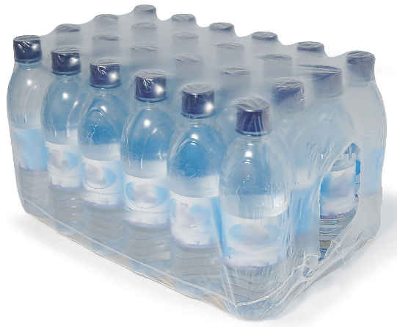 Design an Educational Brochure about

Reducing Solid Waste and Hazardous Waste

____ Write question #’s with answer on your brochure.

Holt textbook (my.hrw.com) Ch 19-1 Solid Waste

_____ 1. Provide a picture of a landfill with labeled parts.

Describe a positive and negative outcome. 6 pts

Holt textbook (my.hrw.com), Ch 19-2 Reducing Solid Waste

_____ 2. Identify 3 ways you can produce less waste. 6

_____ 3. Describe how you can use your consumer buying power to reduce solid waste. 3

_____ 4. List the steps that an item must go through to be recycled. 3

_____ 5. Provide before and after pictures of a new product that has been made using something that has been

recycled. Explain. 5

_____ 6. List 2 benefits of composting. 4

_____ 7. Name 1 advantage and 1 disadvantage to producing degradable plastic. 4

Holt textbook (my.hrw.com), Ch 19-3 Hazardous Waste

_____ 8. Name 2 characteristics of hazardous waste. 4

_____ 9. Provide pictures (and names) of 3 types of hazardous wastes. 6

_____ 10. Name and describe 1 law that governs hazardous waste. 4

_____ 11. Describe 2 ways to treat hazardous waste safely. 4

_____ 12. List 2 alternative ways that are used to dispose of hazardous waste and describe the negative

effects associated with each. 4

_____ 13. List 2 household hazardous wastes and describe how to properly dispose of them. 4